COLLAGE NETWORK DESIGN



COURT ROAD NETWORKZ SYSTEMS NAGERCOIL, KANYAKUMARI

STUDENT NAME : R P MITHUN

STUDENT ID : NSNCV0423020

STAFF NAME : ANTONET REETA COURSE NAME : CCNA

DATE : 17-7-2023

TABLE OF CONTENT

|  |  |  |
| --- | --- | --- |
| Serial.No | TITTLE | Page.No |
| 1 | Abstract | 1 |
| 2 | Acknowledgment |  |
| 3 | Introduction |  |
| 4 | Network Requirement |  |
| 5 | Hardware & software requirement |  |
| 6 | Switch & router Configuration |  |
| 7 | Network Topology |  |
| 8 | Output Results |  |
| 9 | Conclusion |  |

**Abstract**

The Primary purpose of a computer network is to share resources. A computer network is referred to as client/server if (at least) one of the computers is used to server other computer referred to as client. Beside the computers,other types of devices can be part of the network. In the early day of networking there will be once central server that contains the data and all the clients can access this data through a Network Interface card. Later on client server architecture came into existence, where still burden is there on the server machine. To avoid the disadvantages in distributed computing was introduced which reduce the burden on the server by providing work sharing capabilities. This paper describes how the concept of distributed computing came into existence based on the advantages and disadvantages that raised in earlier networking concepts. The concepts of distributed computing speaks that once data is available within the server (s), it should be able to be accessed and processed from any kind of client device like computer, computer, mobile phone, PDA, etc.

# ACKNOWLEDGMENT

First we would like to thank the Almighty for his wonderful presence with us throughtout the completion of the project and making it as a successful one.

We are expressing our deep gratitude to **COURT ROAD NETWORKZ SYSTEMS INSTITUTION**

which provided us an opportunity in fulfilling our most cherished desire in reaching our goal.

This is a great pleasure to express our deep sense of gratitude and thanks to our guide **MISS ANTONET REETA** for her valuable ideas, instantaneous help, effective support and continued encouragement which enabled for the successful completion of the project

W e g r a t e f u l l y r e m e m b e r t h e a v a i l a b l e suggestion of our respective staff for their valuable and timely guidance for the completion of the project.

W e g r a t e f u l l y r e m e m b e r t h e a v a i l a b l e suggestion of our respective staff for their valuable and timely guidance for the completion of this project. Finally we would like to express our sincere thanks to all our friends who gave good ideas not suggestions for our project.

# INTRODUCTION

Networking is referred as connecting computers electrically for the purpose of sharing i n f o r m a t i o n . R e s o u r c e s s u c h a s a f i l e , application, printer & software. The advantage of networking can be seen in the terms of security, efficiency, manageablility and cost as it allows collaboration between user in a wide range. The switches and router this device that play and important role in data transfer from one place to another using different technology such ad radio waves & wire.

# Networking Requirement

1. The active networking components (Routers (1941,2811), Switches, Ip telephone,pc,

servers) with quantity.

1. The IP network design for each department.
2. Dynamic IP addressing design for all networks
3. Identify the configuration and features, wherever appropriate, which is required on the active components to setup the network.
4. Analysis, identification and explantion of methodologies to use for access restriction and internet sharing.

# HARDWARE REǪUIREMENT

* Processor AMD PRO A4-4350B R4,5 COMPUTE

CORES 2C

+3G 2.50GHz

* RAM 4.00 GB
* System Type 64-bit operating system

# REǪUIREMENT

1. The following use cisco packet tracer to design and implement the network solution
2. Use EIGRP as the routing protocol
3. Configure AAA in principal room and telnet in staff room
4. Four building each building has four floors each floor has one ip telephone and five pc
5. There are four servers each servers connected to one building
6. Class A type IP address used in every department
7. Device in each building are required to communicate with each other
8. Test communication ensure everything configured is working as expected

# SOFTWARE REǪUIREMENT

* CISCO Packet Tracer

# ROUTER CONFIGURATION

ROUTER 1

hostname building1

ip dhcp pool sec1

network 18.0.0.0 255.0.0.0

default-router 18.0.0.1

no ip cef

no ipv6 cef

license udi pid CISCO1941/K9 sn FTX152457YS-

spanning-tree mode pvst

interface GigabitEthernet0/0

ip address 18.0.0.1 255.0.0.0

duplex auto

speed auto

interface GigabitEthernet0/1

no ip address

duplex auto

speed auto

shutdown

interface Serial0/0/0

ip address 60.0.0.1 255.0.0.0

ip helper-address 20.0.0.2

ip helper-address 18.0.0.2

interface Serial0/0/1

ip address 50.0.0.1 255.0.0.0

clock rate 2000000

interface Serial0/1/0

ip address 10.0.0.1 255.0.0.0

interface Serial0/1/1

ip address 40.0.0.2 255.0.0.0

clock rate 2000000

interface Vlan1

no ip address

shutdown

router eigrp 1

network 10.0.0.0

network 40.0.0.0

network 50.0.0.0

network 60.0.0.0

ip classless

ip flow-export version 9

no cdp run

line con 0

line aux 0

line vty 0 4

login

end

ROUTER 2

hostname Router

ip dhcp excluded-address 1.0.0.4 1.0.0.8

ip dhcp excluded-address 2.0.0.4 2.0.0.8

ip dhcp pool floor1

network 1.0.0.0 255.0.0.0

default-router 1.0.0.1

ip dhcp pool floor2

network 2.0.0.0 255.0.0.0

default-router 2.0.0.1

Router#show running-config

Building configuration...

Current configuration : 1443 bytes

version 15.1

no service timestamps log datetime msec

no service timestamps debug datetime msec

no service password-encryption

hostname Router

ip dhcp excluded-address 1.0.0.4 1.0.0.8

ip dhcp excluded-address 2.0.0.4 2.0.0.8

ip dhcp pool floor1

network 1.0.0.0 255.0.0.0

default-router 1.0.0.1

ip dhcp pool floor2

network 2.0.0.0 255.0.0.0

default-router 2.0.0.1

Router#sh running-config

Building configuration...

Current configuration : 1443 bytes

version 15.1

no service timestamps log datetime msec

no service timestamps debug datetime msec

no service password-encryption

hostname Router

ip dhcp excluded-address 1.0.0.4 1.0.0.8

ip dhcp excluded-address 2.0.0.4 2.0.0.8

ip dhcp pool floor1

network 1.0.0.0 255.0.0.0

default-router 1.0.0.1

ip dhcp pool floor2

network 2.0.0.0 255.0.0.0

default-router 2.0.0.1

aaa new-model

aaa authentication login default group tacacs+

aaa authentication enable default group tacacs+

no ip cef

no ipv6 cef

username admin password 0 admin

license udi pid CISCO1941/K9 sn FTX1524QIMR-

spanning-tree mode pvst

interface GigabitEthernet0/0

ip address 1.0.0.1 255.0.0.0

ip helper-address 18.0.0.2

duplex auto

speed auto

interface GigabitEthernet0/1

ip address 2.0.0.1 255.0.0.0

duplex auto

speed auto

interface Serial0/0/0

no ip address

clock rate 2000000

shutdown

interface Serial0/0/1

ip address 50.0.0.1 255.0.0.0

clock rate 2000000

interface Serial0/1/0

no ip address

clock rate 2000000

shutdown

interface Serial0/1/1

no ip address

clock rate 2000000

shutdown

interface Vlan1

no ip address

shutdown

router eigrp 1

network 50.0.0.0

network 1.0.0.0

network 2.0.0.0

ip classless

ip flow-export version 9

no cdp run

tacacs-server host 1.0.0.13

tacacs-server key cisco

line con 0

line aux 0

line vty 0 4

end

Router 3

hostname Router

ip dhcp excluded-address 3.0.0.2

ip dhcp excluded-address 4.0.0.2

ip dhcp pool floor1

network 3.0.0.0 255.0.0.0

default-router 3.0.0.1

ip dhcp pool floor2

network 4.0.0.0 255.0.0.0

default-router 4.0.0.1

aaa new-model

aaa authentication login default group tacacs+

aaa authentication enable default group tacacs+

no ip cef

no ipv6 cef

username admin password 0 admin

license udi pid CISCO1941/K9 sn FTX152476DK-

spanning-tree mode pvst

interface GigabitEthernet0/0

ip address 3.0.0.1 255.0.0.0

duplex auto

speed auto

interface GigabitEthernet0/1

ip address 4.0.0.1 255.0.0.0

duplex auto

speed auto

interface Serial0/0/0

ip address 60.0.0.2 255.0.0.0

clock rate 2000000

interface Serial0/0/1

ip address 50.0.0.2 255.0.0.0

interface Serial0/1/0

no ip address

clock rate 2000000

shutdown

interface Serial0/1/1

no ip address

interface Vlan1

no ip address

shutdown

router eigrp 1

network 3.0.0.0

network 4.0.0.0

network 60.0.0.0

network 50.0.0.0

ip flow-export version 9

tacacs-server host 3.0.0.3

tacacs-server key cisco

line con 0

line aux 0

line vty 0 4

end

ROUTER 4

hostname Router

ip dhcp excluded-address 5.0.0.2 5.0.0.8

ip dhcp excluded-address 6.0.0.2 6.0.0.8

ip dhcp pool floor1

network 5.0.0.0 255.0.0.0

default-router 5.0.0.1

ip dhcp pool floor2

network 6.0.0.0 255.0.0.0

default-router 6.0.0.1

aaa new-model

aaa authentication login default group tacacs+

aaa authentication enable default group tacacs+

no ip cef

no ipv6 cef

username admin password 0 admin

icense udi pid CISCO1941/K9 sn FTX1524T00V-

spanning-tree mode pvst

interface GigabitEthernet0/0

ip address 5.0.0.1 255.0.0.0

duplex auto

speed auto

interface GigabitEthernet0/1

ip address 6.0.0.1 255.0.0.0

duplex auto

speed auto

interface Serial0/0/0

ip address 70.0.0.2 255.0.0.0

interface Serial0/0/1

ip address 80.0.0.1 255.0.0.0

clock rate 2000000

interface Serial0/1/0

no ip address

clock rate 2000000

shutdown

interface Serial0/1/1

no ip address

clock rate 2000000

shutdown

interface Vlan1

no ip address

shutdown

router eigrp 1

network 5.0.0.0

network 6.0.0.0

network 70.0.0.0

network 80.0.0.0

ip classless

ip flow-export version 9

tacacs-server host 18.0.0.2

tacacs-server key cisco

line con 0

line aux 0

line vty 0 4

end

ROUTER 5

hostname Router

ip dhcp excluded-address 7.0.0.2 7.0.0.3

ip dhcp excluded-address 8.0.0.2 8.0.0.3

ip dhcp pool floor3

network 7.0.0.0 255.0.0.0

default-router 7.0.0.1

ip dhcp pool floor4

network 8.0.0.0 255.0.0.0

default-router 8.0.0.1

aaa new-model

aaa authentication login default group tacacs+

aaa authentication enable default group tacacs+

no ip cef

no ipv6 cef

username admin password 0 admin

license udi pid CISCO1941/K9 sn FTX1524S469-

spanning-tree mode pvst

interface GigabitEthernet0/0

ip address 7.0.0.1 255.0.0.0

duplex auto

speed auto

interface GigabitEthernet0/1

ip address 8.0.0.1 255.0.0.0

duplex auto

speed auto

interface Serial0/0/0

no ip address

clock rate 2000000

interface Serial0/0/1

ip address 80.0.0.2 255.0.0.0

interface Serial0/1/0

no ip address

clock rate 2000000

shutdown

interface Serial0/1/1

no ip address

clock rate 2000000

shutdown

interface Vlan1

no ip address

shutdown

router eigrp 1

network 8.0.0.0

network 7.0.0.0

network 80.0.0.0

ip classless

ip flow-export version

tacacs-server host 18.0.0.2

tacacs-server key cisco

line con 0

line aux 0

line vty 0 4

end

ROUTER 6

hostname Router

ip dhcp excluded-address 9.0.0.2 9.0.0.3

ip dhcp excluded-address 11.0.0.2 11.0.0.3

ip dhcp pool floor1

network 9.0.0.0 255.0.0.0

default-router 9.0.0.1

ip dhcp pool floor2

network 11.0.0.0 255.0.0.0

default-router 11.0.0.1

aaa new-model

aaa authentication login default group tacacs+

aaa authentication enable default group tacacs+

no ip cef

no ipv6 cef

username admin password 0 admin

license udi pid CISCO1941/K9 sn FTX1524AAWR-

spanning-tree mode pvst

interface GigabitEthernet0/0

ip address 9.0.0.1 255.0.0.0

duplex auto

speed auto

interface GigabitEthernet0/1

ip address 11.0.0.1 255.0.0.0

duplex auto

speed auto

interface Serial0/0/0

no ip address

clock rate 2000000

shutdown

interface Serial0/0/1

ip address 100.0.0.2 255.0.0.0

clock rate 2000000

interface Serial0/1/0

no ip address

clock rate 2000000

shutdown

interface Serial0/1/1

no ip address

clock rate 2000000

shutdown

interface Vlan1

no ip address

shutdown

router eigrp 1

network 100.0.0.0

network 9.0.0.0

network 11.0.0.0

ip classless

ip flow-export version 9

tacacs-server host 19.0.0.2

tacacs-server key cisco

line con 0

line aux 0

line vty 0 4

end

ROUTER 7

hostname Router

ip dhcp excluded-address 12.0.0.2 12.0.0.3

ip dhcp excluded-address 12.0.0.2 13.0.0.3

ip dhcp excluded-address 13.0.0.2 13.0.0.3

ip dhcp excluded-address 12.0.0.2

ip dhcp excluded-address 12.0.0.3 12.0.0.4

ip dhcp pool floo03

network 12.0.0.0 255.0.0.0

default-router 12.0.0.1

ip dhcp pool floo04

network 13.0.0.0 255.0.0.0

default-router 13.0.0.1

ip dhcp pool floor3

network 12.0.0.0 255.0.0.0

default-router 12.0.0.1

ip dhcp pool floor4

network 12.0.0.0 255.0.0.0

default-router 12.0.0.1

aaa new-model

aaa authentication login default group tacacs+

aaa authentication enable default group tacacs+

no ip cef

no ipv6 cef

username admin password 0 admin

license udi pid CISCO1941/K9 sn FTX15249331-

spanning-tree mode pvst

interface GigabitEthernet0/0

ip address 12.0.0.1 255.0.0.0

duplex auto

speed auto

interface GigabitEthernet0/1

ip address 13.0.0.1 255.0.0.0

duplex auto

speed auto

interface Serial0/0/0

ip address 90.0.0.2 255.0.0.0

clock rate 2000000

interface Serial0/0/1

ip address 100.0.0.1 255.0.0.0

interface Serial0/1/0

no ip address

clock rate 2000000

shutdown

interface Serial0/1/1

no ip address

clock rate 2000000

shutdown

interface Vlan1

no ip address

shutdown

router eigrp 1

network 90.0.0.0

network 100.0.0.0

network 12.0.0.0

network 13.0.0.0

ip classless

ip flow-export version 9

tacacs-server host 18.0.0.2

tacacs-server key cisco

line con 0

line aux 0

line vty 0 4

end

ROUTER 8

hostname building4

aaa new-model

aaa authentication login default group tacacs+

aaa authentication enable default group tacacs+

no ip cef

no ipv6 cef

username admin password 0 admin

license udi pid CISCO1941/K9 sn FTX1524NYPG-

spanning-tree mode pvst

interface GigabitEthernet0/0

ip address 21.0.0.1 255.0.0.0

duplex auto

speed auto

interface GigabitEthernet0/1

no ip address

duplex auto

speed auto

shutdown

interface Serial0/0/0

ip address 110.0.0.1 255.0.0.0

interface Serial0/0/1

no ip address

clock rate 2000000

shutdown

interface Serial0/1/0

ip address 30.0.0.2 255.0.0.0

clock rate 2000000

interface Serial0/1/1

ip address 40.0.0.1 255.0.0.0

interface Vlan1

no ip address

shutdown

router eigrp 1

network 110.0.0.0

network 30.0.0.0

network 40.0.0.0

ip classless

ip flow-export version 9

no cdp run

tacacs-server host 21.0.0.2

tacacs-server key cisco

line con 0

line aux 0

line vty 0 4

End

Router 9

hostname Router

ip dhcp excluded-address 14.0.0.3

ip dhcp excluded-address 15.0.0.3

ip dhcp pool floor1

network 14.0.0.0 255.0.0.0

default-router 14.0.0.1

ip dhcp pool floor2

network 15.0.0.0 255.0.0.0

default-router 15.0.0.1

aaa new-model

aaa authentication login default group tacacs+

aaa authentication enable default group tacacs+

no ip cef

no ipv6 cef

username admin password 0 admin

license udi pid CISCO1941/K9 sn FTX1524836P-

spanning-tree mode pvst

interface GigabitEthernet0/0

ip address 15.0.0.1 255.0.0.0

duplex auto

speed auto

interface GigabitEthernet0/1

ip address 14.0.0.1 255.0.0.0

duplex auto

speed auto

interface Serial0/0/0

ip address 110.0.0.2 255.0.0.0

clock rate 2000000

interface Serial0/0/1

ip address 120.0.0.1 255.0.0.0

interface Serial0/1/0

no ip address

clock rate 2000000

shutdown

interface Serial0/1/1

no ip address

clock rate 2000000

shutdown

interface Vlan1

no ip address

shutdown

router eigrp 1

network 120.0.0.0

network 110.0.0.0

network 14.0.0.0

network 15.0.0.0

ip classless

ip flow-export version 9

tacacs-server host 21.0.0.2

tacacs-server key cisco

line con 0

line aux 0

line vty 0 4

End

# NETWORK TOPOLOGY

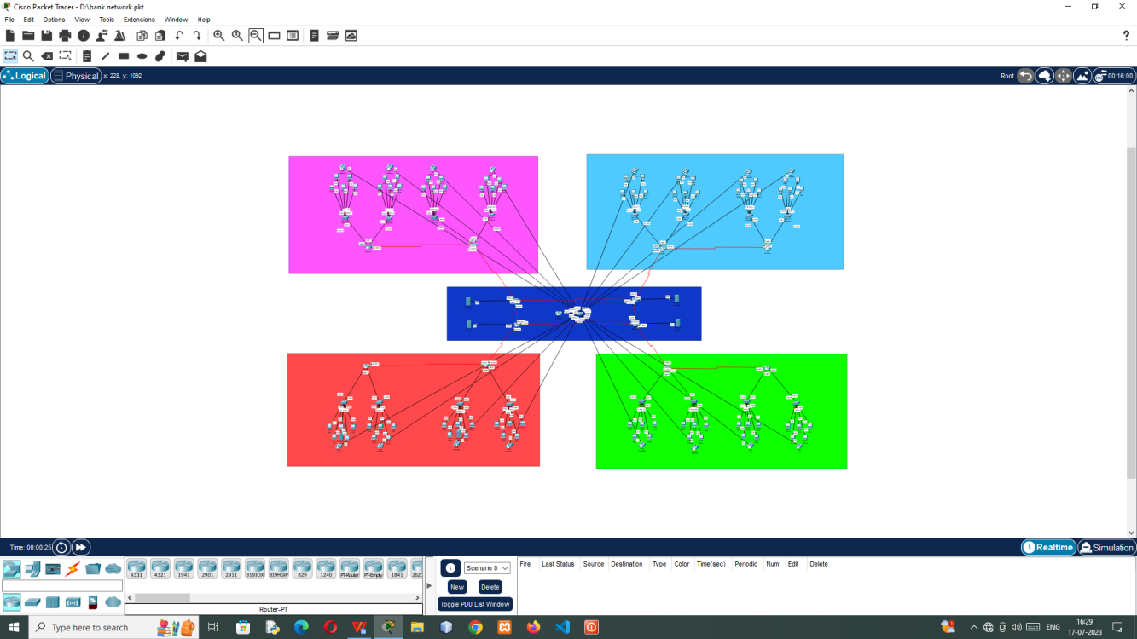

COMMUNCATION BETWEEN PC

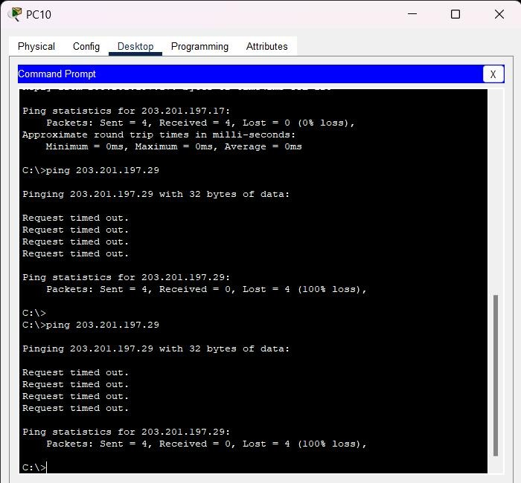

#### COMMUCATION BETWEEN TELEPHONE

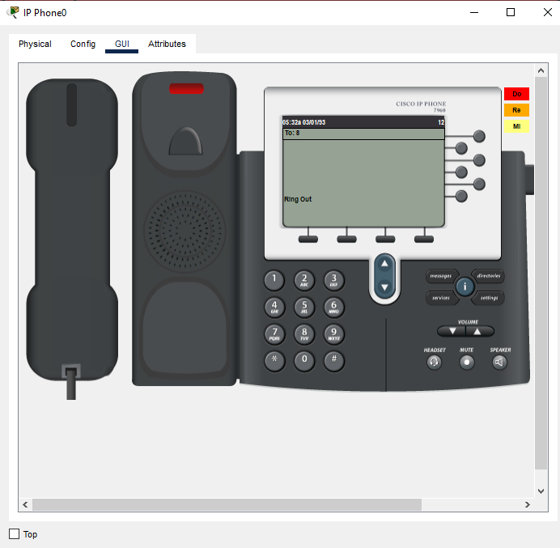

**AAA IN ROUTER**

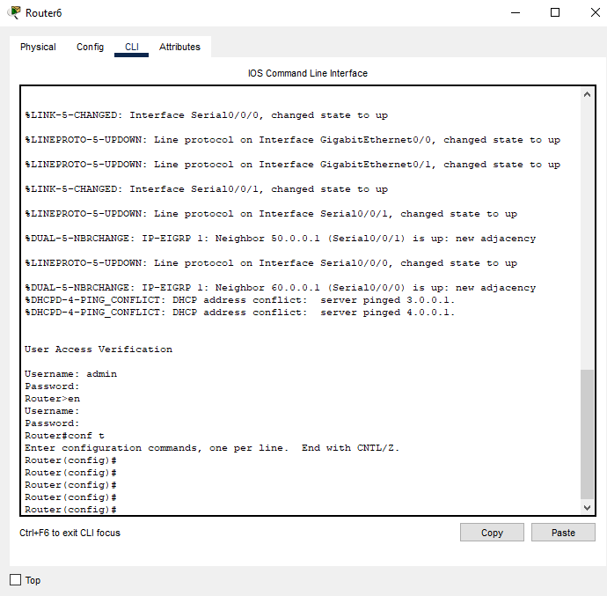

**AAA IN PC**

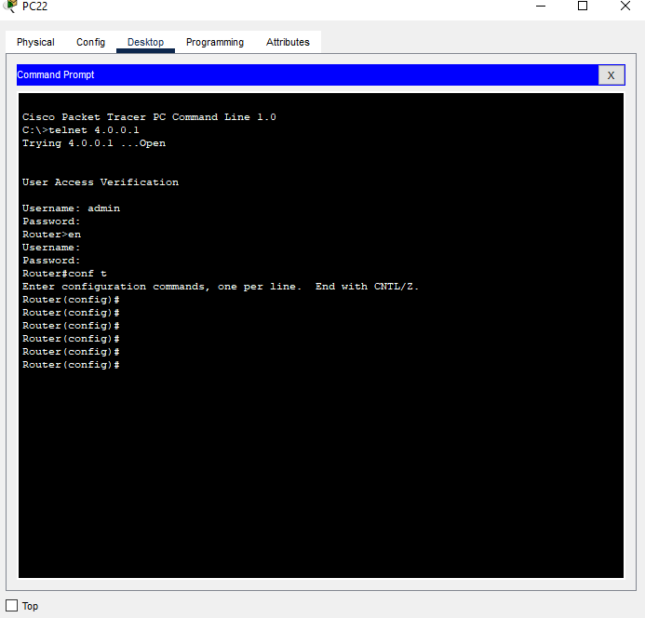

**CONCLUSION**

The whole network provide the convenient and secure way for the entire users of the bank and use better convenient way to access in order to get uninterrupted network, especially vlan & inter-vlan concept for the particular switches.